# Assignment 2

## Task 1

### Portrait Landscape

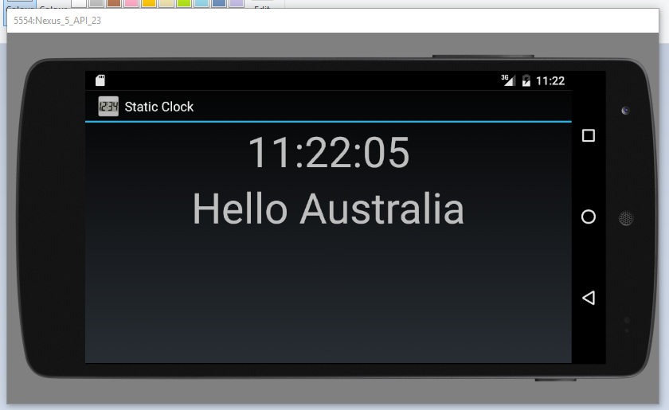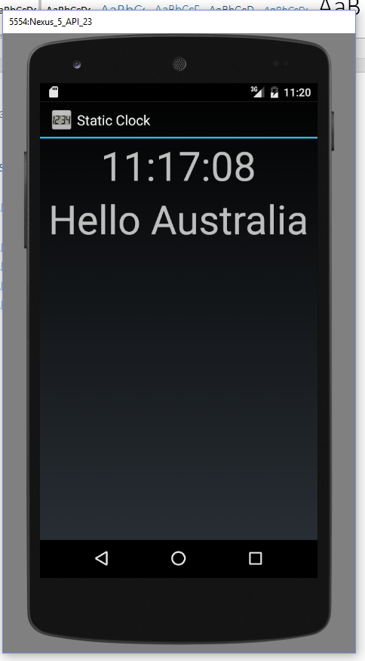

1. When you change the screen orientation. The app deletes and creates a new activity of the current view of the app. It then activates the onCreate() method which sets the current time and then updates the text.
2. The differences are
   1. Resume means the app was currently pause so it changed the state to resume which then retrieves the relevant data to continue using the app
   2. Pause sets the state to pause all operations and then set up a backlog of data which it will use when you resume the app.
   3. Stop means it exits the program and if there is any data not needed it deletes it.

## Task 2

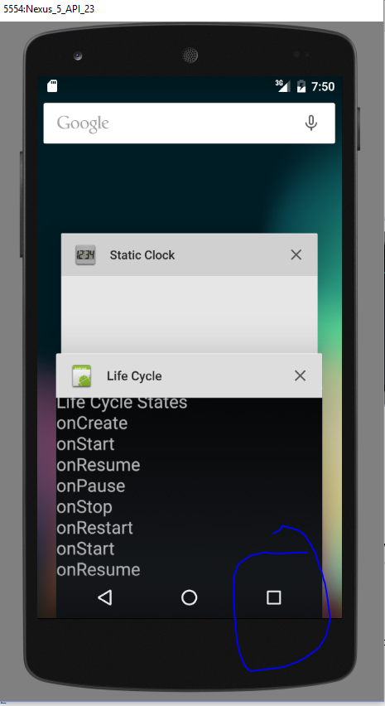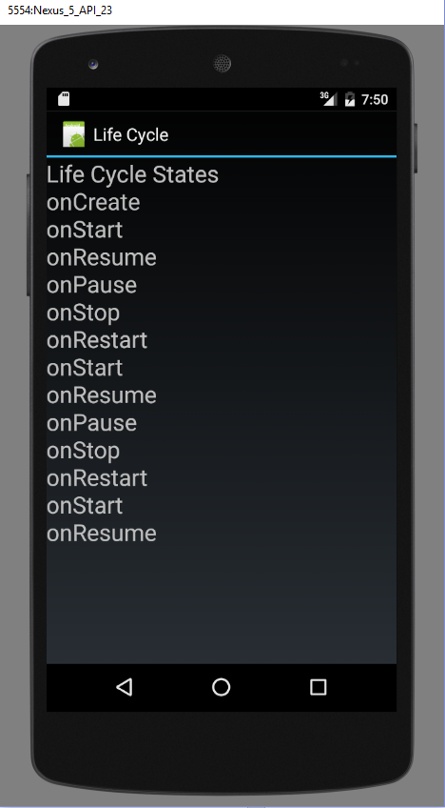

By pressing the app button on the right it opens a menu which has a list of paused apps and when you click on the app it will then trigger the restart function which then restarts the app but not remove the text.

## Task 3

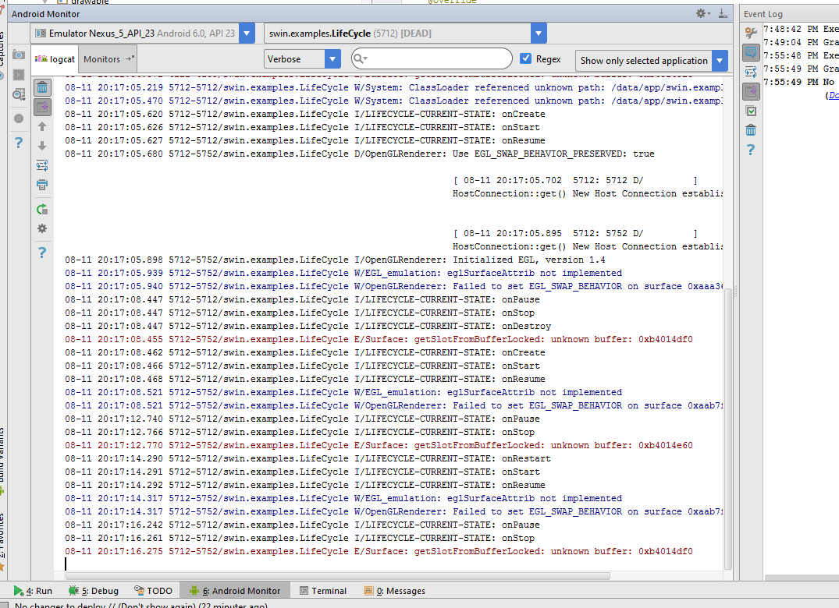

When you change orientation of the screen. The onDestory() state destroys the current instance of the app’s activity. Due to the app destroying the last activity. Reinstates a new intent of the current activity and the only states that have run are onCreate(), onStart() and the onResume() states.

## Task 4

The string.xml file is a great tool if you want your app in different languages. If you set up multiple string folders with the language code, you’re able to dynamically update the app according to the phone’s language setting. So this enables you to reach multiple markets without having people to look at a translator to see what your text says.

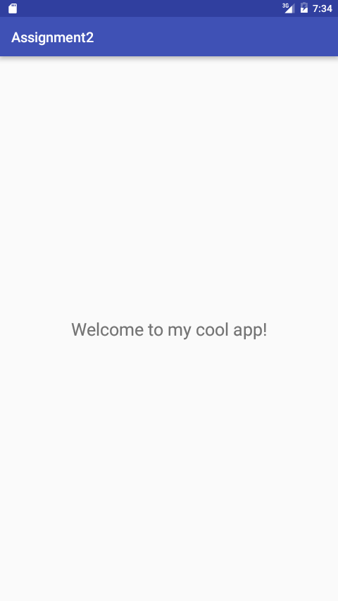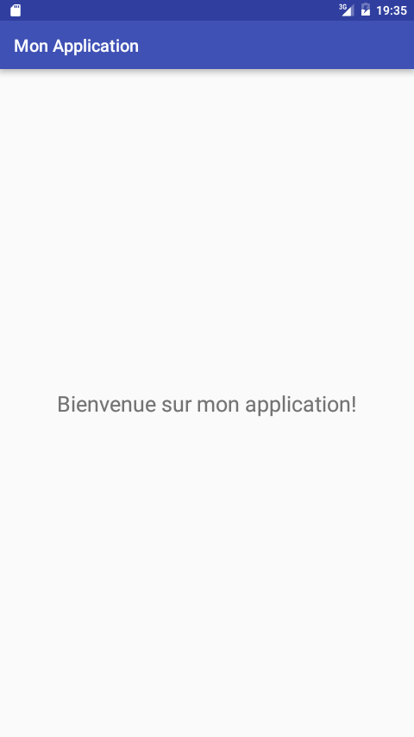

## Task 5

